**Weight Vector:**

Weight vector is W(Star) i.e. most optimal value for w and it and d-dimensional vector.

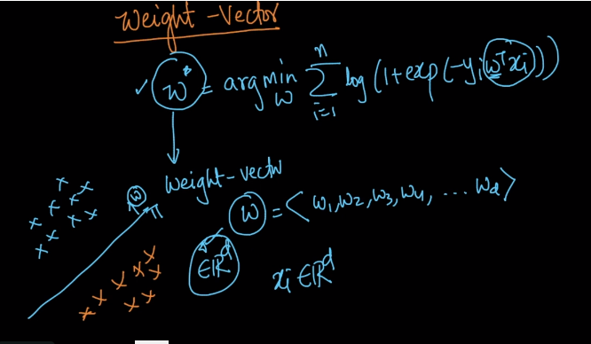

We are using dimension and features interchangeably.

So to understand weight vector we can say it is the vector of weights associated with each feature.

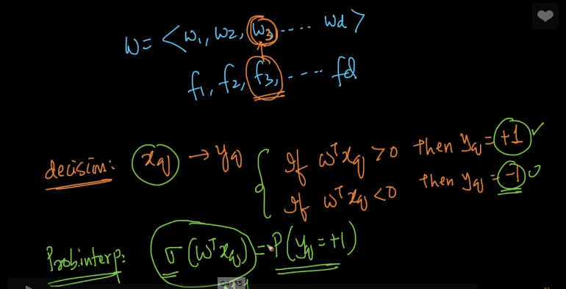

And so we saw that how we determine the value of Yq (class label) when we saw geometric interpretation

And we also saw probabilistic interpretation when we saw sigmoid function.

**Let’s see interpretation of w:**

Case 1: Suppose our Wi is positive than if Xqi increases so WiXqi should also increase i.e. Summation for WiXqi will also increase and which will result in increase of Sigmoid function of WtXq

And so will the probability of Yq = 1 will also increase.

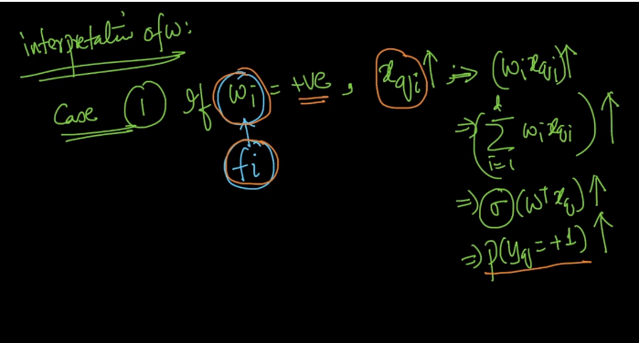

**So in simple words if we say that on increasing Xqi , P(Yq = 1) also increases.**

Lets take Case 2:

It is totally a vice versa for Case 1 as we can see in below image.

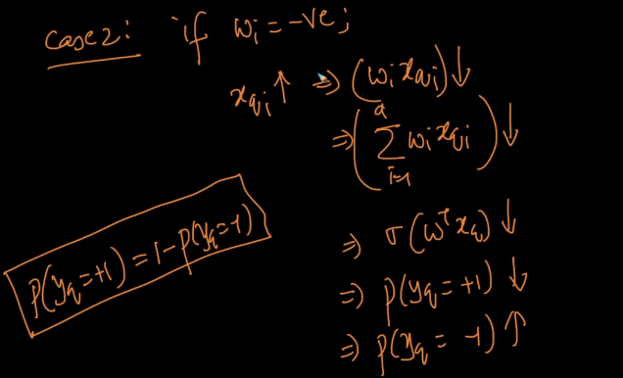

**So here when our Wi is negative and so on increasing Xqi the probability of Yq = +1 decreases and so the probability of P(Yq = -1) increases.**

**So we can say that if weight corresponding to feature i is positive than given a query point if its i’th feature increases than the value for P(Yq = +1) increases and vice versa.**

Comments:

